**ICBA Fall Webinar Series**

**General Merchandise Buyer2Buyer Highlights**

When ICBA buyers get together, you are in for a treat of ideas being exchanged! As one buyer noted, “It’s good to talk with other stores between ICBA meetings”.

November’s Buyer2Buyer calls were no exception to the rule as buyers shared lively discussions on what’s hot and what’s not across all GM categories! Thanks to all who participated and special thanks to our facilitators, Aondria Armstrong from University of Tennessee, Jonell Harper from KU Bookstore, Samantha Palmer from Flagler’s Legacy, Meredith Schreiber from Chemeketa, Emmie Hughes from University of Arizona, and Cassie Wherry from Grinnell.

**Buyer2Buyer - Supplies**

* Paper products: Balance of low-price commodities with higher priced/quality plain or imprinted notebooks. Mixed reports on planners but positive on “systems” like Erin Condren (an ICBA partner), Happy Planner, Pierre Belvedere (Roaring Spring). Premium line like Michael Roger decomposition comp books and spirals, Exaclair, 5 Star, Miquel Riuz (Roaring Spring), WhiteLines (Roaring Spring), Tree Free by BarCharts (https://www.tree-free.com/stationery/journal-notebooks-for-writing/) and Rite in the Rain doing amazingly well in spite of high retail price points.
* Goggle sales robust as a class requirement.
* KU had tremendous success with having binders listed on class adoptions where course packs were required.
* Boost in supply sales with logo lab coats.
* Line queues can be a great spot for impulse supply items. NDSU has $1, $3, and $5 bins (like Target) for everything from stickers, to items they source from Dollar Tree.
* Smaller stores continue to struggle with freight terms. Distributor premium prices may be worth it to maintain inventory turns.
* Campus delivery key to success with departments.
* Second semester sales doing well as there is a lack of competition from mass-market and other retail channels.
* Shout out for Social Media users; Canva.com is a time-saving tool to check out.

**Buyer2Buyer – Technology Products**

* Everyone is looking for a way to compete and succeed in the PC category.
* Ratio of wired to wireless earbuds and headphones range from 2:1 to 4:1 for callers. Sweet spot for wireless is $19.99-$29.99 and $4-$8 wired. Many were surprised by the success of the $159 ear pods.
* 32GB seems to be the sweet spot for flash drives.
* Attachment rates for sleeves can be a good sales boost – as much as 1 sleeve sold for every 2 computers. Herschel and Case Logic notable good sellers. Katie shared iBenzer contact for hard shell cases.
* Gaming: stores sticking with accessories such as Roccat, Razer, Lucid Sound and others sourced through D&H. Few venture into actual game sales
* Horrible delays in getting Apple watches 10-12 weeks. Fitbit and Gamin sales have dropped up significantly
* Stores searching for workable trade-in solutions
* Logo pop sockets, phone wallets can help build margin.

**Buyer2Buyer - Cosmetics**

An ICBA first-ever call for cosmetics buyers! Callers focused on exchanging contacts for manufacturers and representatives that can help expand the category.

* While product availability is challenging, it is definitely a category that brings in traffic.
* Skin care is an important segment of the business.
* With dedicated sales counters, staffing is very important as customers want to develop a relationship with their beauty and skin care consultants to discuss their personal needs.
* New interest in men’s skincare and shaving needs.

**Buyer2Buyer - Gifts**

* Hydroflask is killing it everywhere!
* Mini-decals that are small versions of standard logo decals. Popular for decorating water bottles and laptops.
* Board games with bi-weekly game night and free game rentals
* Themed gift assortments like Harry Potter doing well at Wartburg College
* Adhesive phone ID holders (MCM) doing well.
* Fun socks doing well – socks with slogans!
* Mixing gifts with trade book section
* Licensing giving some push back on non-school colors.
* $5 value price point on Coffee Mug for alumni
* Gift pack of coffee mugs with Molly & You single-serve cake mix packets
* Leggings from yelete.com and magicscarf.com have been successful accessories.

**Buyer2Buyer - Apparel**

* Buyers stocking larger sizes – 3X and up. Particularly effective merchandising on dedicated fixtures during parent weekends. One store using a local vendor for smaller runs for the big sizes. 3X doing particularly well in t-shirts.
* Quarter Zip fleece promotions particularly successful during fall promotional events and with on-line orders.
* Champion’s Pack-n-Go jacket having tremendous success in school colors as well as fashion colors. Looking for good sales in spring with white Pack-n-Go jacket.
* Sherpa doing well at some stores but a few noting sales have peaked. Looking to expand into blankets and pillows to extend Sherpa interest.
* Oatmeal remains strong.
* Cropped styles anticipated to do well.
* Corded Cotton a hit and miss depending on the brand execution.
* Tri-blend shirts for women trending up.
* Vintage, soft trucker’s mesh remains a best seller along with Legacy’s popular styles. Flat bill’s have died off but the classic “dad’s hat” is doing very well.
* Bucket hats still doing well.
* MV/The Game beanie pom hat doing well.
* A few stores in the small store category, mentioned being up in imprints attributed to new logos, store remodel.
* Basic graphics and $9.99 price points t-shirts in school colors and non-traditional colors do quite well.
* Mixed reactions to performance wear sales, particularly related to Under Armour.
* KU color codes clearance to a discount chart, much like DSW stores.
* Buyers finding more opportunities for deals throughout the year so spreading out the buying to take advantage of seasonal deals and closeouts.
* UC Santa Cruz Bay Tree Bookstore sold 2,000 long-sleeve t-shirts in one week during the annual BOGO sale.

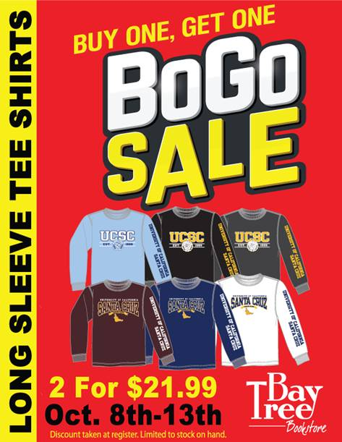

* UC Santa Cruz – Bay Tree Bookstore’s 7th Annual EPIC Sale coming December 12th. $140,000 in sales in one day!

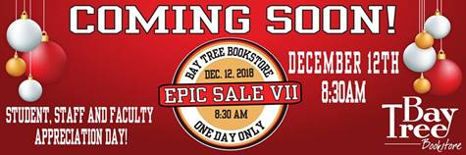

* Two bestsellers from NDSU Bookstore: the Foco tropical print shirt and CI Sport’s Marled Sweatpant.

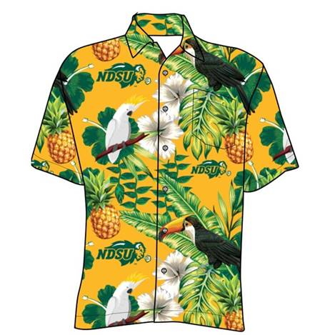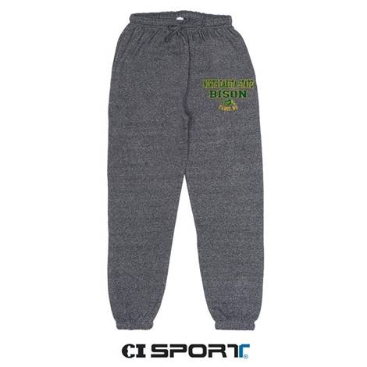

Questions? Contact Paula Haerr at PaulaHaerr@ICBAinc.com